# React

# 6.ReactJS-HOL

# Additional HandsOn

**Cognizant Academy teams want to maintain a list of trainers along with their expertise in a SPA using React as the technology. You are assigned the task of creating this React app.**

1. Create a new React app using *create-react-app* tool with the as “TrainersApp”

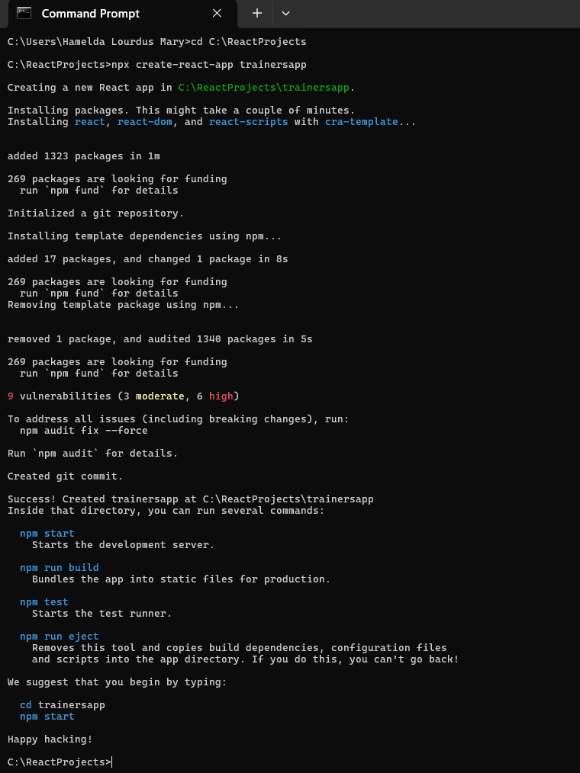

1. Open the application using the VS Code

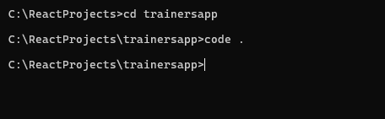

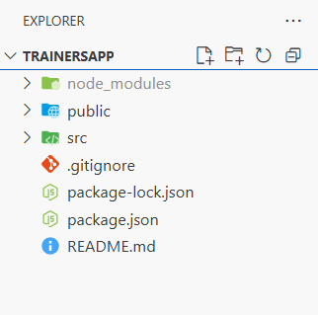

1. Add a new file called *trainer.js* inside the **src folder** and define a class named as “Trainer”

**Trainer.js**

class Trainer {

constructor(trainerId, name, email, phone, technology, skills) {

this.trainerId = trainerId;

this.name = name;

this.email = email;

this.phone = phone;

this.technology = technology;

this.skills = skills;

}

}

export default Trainer;

1. Create a new TrainersMock.js file which will contain the mock trainer data.

**TrainersMock.js**

import Trainer from "./Trainer";

const trainersMock = [

new Trainer('t-syed8', 'Syed Khaleelullah', 'khaleelullah@cognizant.com', '97676516962', '.NET', ['C#', 'SQL Server', 'React', '.NET Core']),

new Trainer('t-jojo', 'Jojo Jose', 'jojoj@cognizant.com', '9891799231', 'Java', ['Java', 'JSP', 'Angular', 'Spring']),

new Trainer('t-elisa', 'Elisa Jones', 'elisaj@cognizant.com', '9121122345', 'Python', ['Python', 'Django', 'Angular'])

];

export default trainersMock;

1. Install the support for React router for the dom. Execute the following command.

**npm install react-router-dom@6**

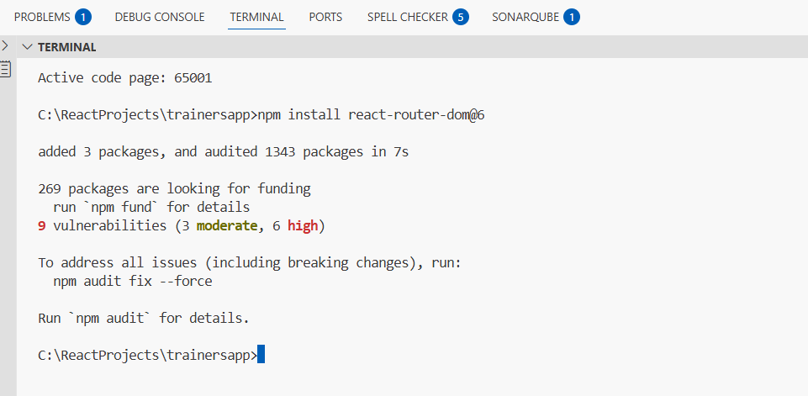

1. **TrainersList.js**

import { Link } from 'react-router-dom';

function TrainersList({ trainers }) {

return (

<div>

<h3>Trainers List</h3>

<ul>

{trainers.map(trainer => (

<li key={trainer.trainerId}>

<Link to={`/trainer/${trainer.trainerId}`}>{trainer.name}</Link>

</li>

))}

</ul>

</div>

);

}

export default TrainersList;

1. **Home.js**

function Home() {

return (

<div>

<h3>Welcome to My Academy trainers page</h3>

</div>

);

}

export default Home;

1. **App.js**

import { BrowserRouter, Routes, Route, Link } from 'react-router-dom';

import Home from './Home';

import TrainersList from './TrainersList';

import TrainerDetail from './TrainerDetail';

import trainersMock from './TrainersMock';

function App() {

return (

<BrowserRouter>

<div>

<h2>My Academy Trainers App</h2>

<nav>

<Link to="/">Home</Link> |{" "}

<Link to="/trainers">Show Trainers</Link>

</nav>

<Routes>

<Route path="/" element={<Home />} />

<Route path="/trainers" element={<TrainersList trainers={trainersMock} />} />

<Route path="/trainer/:id" element={<TrainerDetail />} />

</Routes>

</div>

</BrowserRouter>

);

}

export default App;

1. **TrainerDetail.js**

import { useParams } from 'react-router-dom';

import trainersMock from './TrainersMock';

function TrainerDetail() {

const { id } = useParams();

const trainer = trainersMock.find(t => t.trainerId === id);

if (!trainer) {

return <p>Trainer not found</p>;

}

return (

<div>

<h3>Trainers Details</h3>

<p><strong>{trainer.name} ({trainer.technology})</strong></p>

<p>{trainer.email}</p>

<p>{trainer.phone}</p>

<ul>

{trainer.skills.map((skill, index) => (

<li key={index}>{skill}</li>

))}

</ul>

</div>

);

}

export default TrainerDetail;

1. Build and run the application

**npm start**

**Output:**

* **Home**

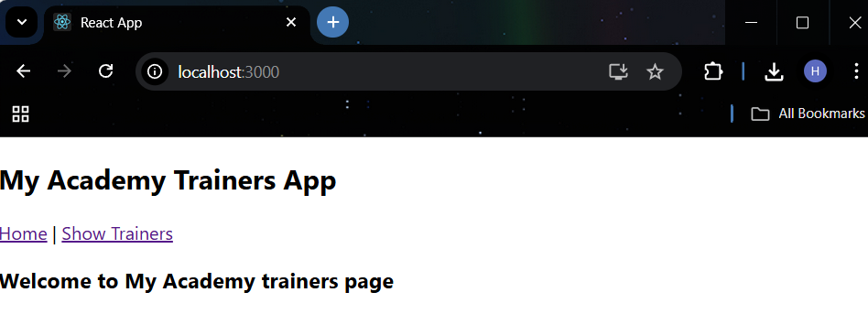

* **Trainers List**

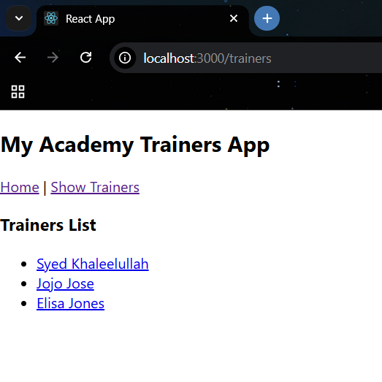

* **Trainer Details**

